Sponger Spirit Shop 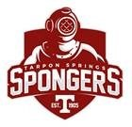

Our school spirit shop is open and new styles are uploaded and ready for purchase.

Check out our spirit wear shop that includes apparel and accessories for all family members.

https://sideline.bsnsports.com/schools/florida/tarponsprings/tarpon-springs-high-school

